SIMATS ENGINEERING
ASSESSMENT TOOL 1- Enumeration Analysis

COURSE CODE: ITA1401 COURSE NAME: Ethical Hacking

COURSE OUTCOME COVERED
CO3: Analyse network services using port scanning, ping sweeps, and enumeration techniques across different operating systems to identify vulnerabilities. (BL3)
Assessment Tool Weightage: 40%

QUESTIONS: 5 Total Marks:100
- The security team has deployed a deliberately vulnerable Linux server, 192.168.56.101 (Metasploitable 2), in an isolated laboratory environment to train penetration testers. As part of the pre-engagement reconnaissance phase, use Nmap to perform comprehensive enumeration of 192.168.56.101. Identify all open ports, running services, service versions, and operating system information. Analyze the purpose of each service and determine which services could provide potential entry points for an attacker. Categorize the discovered services into High, Medium, and Low risk levels based on their exposure and functionality. Explain how the enumeration results could guide a penetration tester in selecting potential attack vectors and exploitation strategies.
- A financial organization wants to assess the security posture of a Windows workstation located at 192.168.56.102 before connecting it to the production network. Using Nmap, enumerate 192.168.56.102 to identify active ports, network services, file-sharing protocols, remote management services, and operating system details. Analyze whether the discovered services comply with the principle of least privilege and identify any services that may unnecessarily increase the attack surface. Discuss how an attacker could leverage the identified services for reconnaissance, lateral movement, or unauthorized access. Based on your findings, propose a set of security hardening measures to improve the system's resilience against cyberattacks.
- An organization hosts a web application on 192.168.56.103 (OWASP Juice Shop Server) and plans to conduct a full penetration test. Before the testing phase begins, the security team must understand the server's network exposure. Using Nmap, perform a detailed enumeration of 192.168.56.103, including host discovery, port scanning, service version detection, operating system fingerprinting, and web service identification. Analyze the discovered services and determine how they support the hosted web application. Evaluate the risks associated with exposed web services, administrative interfaces, and supporting services. Explain how the information gathered during enumeration could be used to identify potential vulnerabilities in the web application environment and recommend measures to minimize exposure
- The network gateway device at 192.168.56.1 serves as the primary access point between the internal laboratory network and external networks. The network administrator suspects that unnecessary management services may be exposed. Using Nmap, conduct a comprehensive enumeration of 192.168.56.1, including port scanning, service detection, operating system fingerprinting, and script-based enumeration. Identify all exposed management interfaces, network services, and accessible resources. Analyze the security implications of exposing services such as SSH, Telnet, SNMP, HTTP, or HTTPS management interfaces. Discuss how attackers could exploit misconfigured management services to gain unauthorized access to the network infrastructure. Based on your analysis, recommend security controls and best practices to secure the gateway device and reduce the risk of compromise.

- The network gateway device at 192.168.56.1 serves as the primary access point between the internal laboratory network and external networks. The network administrator suspects that unnecessary management services may be exposed. Using Nmap, conduct a comprehensive enumeration of 192.168.56.1, including port scanning, service detection, operating system fingerprinting, and script-based enumeration. Identify all exposed management interfaces, network services, and accessible resources. Analyze the security implications of exposing services such as SSH, Telnet, SNMP, HTTP, or HTTPS management interfaces. Discuss how attackers could exploit misconfigured management services to gain unauthorized access to the network infrastructure. Based on your analysis, recommend security controls and best practices to secure the gateway device and reduce the risk of compromise.

Code of Conduct:
I T.S.HARINI(192521067) (Name / Reg No) certify that this submission is my original work and that I have adhered to the guidelines specified for this assessment. I understand that any violation of academic integrity rules will result in disciplinary action.
Signature of the student:
T S HARINI

RUBRICS FOR CALCULATION

Criteria | Weightage (%) | Level 4 (Exemplary) | Level 3 (Proficient) | Level 2 (Developing) | Level 1 (Beginning) | Mark
Conceptual Understanding | 20% | Demonstrates strong understanding of underlying concepts in the simulation | Shows good understanding with minor gaps | Partial understanding; some misconceptions | Lacks understanding of key concepts
Model Design | 25% | Develops accurate, well-structured simulation/model independently | Develops correct model with minor errors | Model is incomplete or requires guidance | Unable to develop a proper model
Tool Usage | 20% | Uses simulation tools effectively with correct setup and execution | Uses tools with minor errors or guidance | Limited ability to use tools properly | Unable to use simulation tools
Analysis of Results | 20% | Provides clear, logical analysis and meaningful interpretation of results | Analysis is reasonable with minor gaps | Superficial analysis; limited interpretation | Unable to analyze or interpret results
Documentation | 15% | Presents results clearly with proper documentation and structured reporting | Documentation is adequate with minor issues | Poorly organized or incomplete documentation | No proper documentation or presentation

Q1. AIM
To perform comprehensive network enumeration of the deliberately vulnerable Linux server 192.168.56.101 (Metasploitable 2) using Nmap, identify open ports, running services, service versions, and operating system information, and analyze the discovered services according to their potential security risk.

OBJECTIVES
- To identify all open TCP ports on the target system.
- To identify the services running on the open ports.
- To determine the versions of the discovered services.
- To identify the operating system of the target.
- To categorize the discovered services into High, Medium, and Low risk.
- To understand how enumeration results can guide penetration-testing activities.

PROCEDURE
Step 1: Check connectivity
First, verify that the target machine is reachable.
ping -c 4 192.168.56.101
If replies are received, the target is reachable.
Step 2: Perform basic port scanning
Run a TCP SYN scan to identify open ports:
sudo nmap -sS 192.168.56.101
Step 3: Perform comprehensive service enumeration
Use Nmap service/version detection:
sudo nmap -sV -sC -p- 192.168.56.101
Where:
- -sV identifies service versions.
- -sC runs Nmap's default scripts.
- -p- scans all TCP ports from 1 to 65535.
Step 4: Identify the operating system
sudo nmap -O 192.168.56.101
For combined enumeration:
sudo nmap -A -p- 192.168.56.101
The -A option enables several advanced detection features, including OS detection, version detection, script scanning, and traceroute.

SERVICE ANALYSIS
1. FTP – Port 21
FTP is used for transferring files. If anonymous access or an outdated/vulnerable FTP implementation is present, it can provide an entry point into the system.
Risk: High
2. SSH – Port 22
SSH provides secure remote administration. Although encrypted, weak credentials or vulnerable versions can potentially allow unauthorized access.
Risk: Medium

3. Telnet – Port 23
Telnet provides remote login but does not encrypt credentials or session data.
Risk: High
4. HTTP – Port 80
The HTTP service hosts web applications. Web servers can expose vulnerable applications, outdated software, misconfigurations, or information useful for further testing.
Risk: High
5. SMB/NetBIOS – Ports 139 and 445
These services provide network file and printer-sharing functionality. Misconfigured or vulnerable SMB services can expose files or provide opportunities for unauthorized access.
Risk: High
6. RPC/NFS – Ports 111 and 2049
RPC and NFS provide remote procedure and network file-sharing functionality. Incorrectly configured NFS exports can expose sensitive files.
Risk: High
7. MySQL – Port 3306
MySQL provides database services. If remotely accessible and poorly secured, it may expose databases or provide another route for unauthorized access.
Risk: High
8. PostgreSQL – Port 5432
PostgreSQL is a database management service. Weak authentication, outdated software, or misconfiguration can increase the attack surface.
Risk: High
9. VNC – Port 5900
VNC provides remote graphical access. Weak authentication or insecure configuration could allow unauthorized remote access.
Risk: High
10. Tomcat/AJP – Ports 8009 and 8180
These services are associated with Java web applications. Vulnerable applications or insecure configurations can provide potential attack vectors.
Risk: High

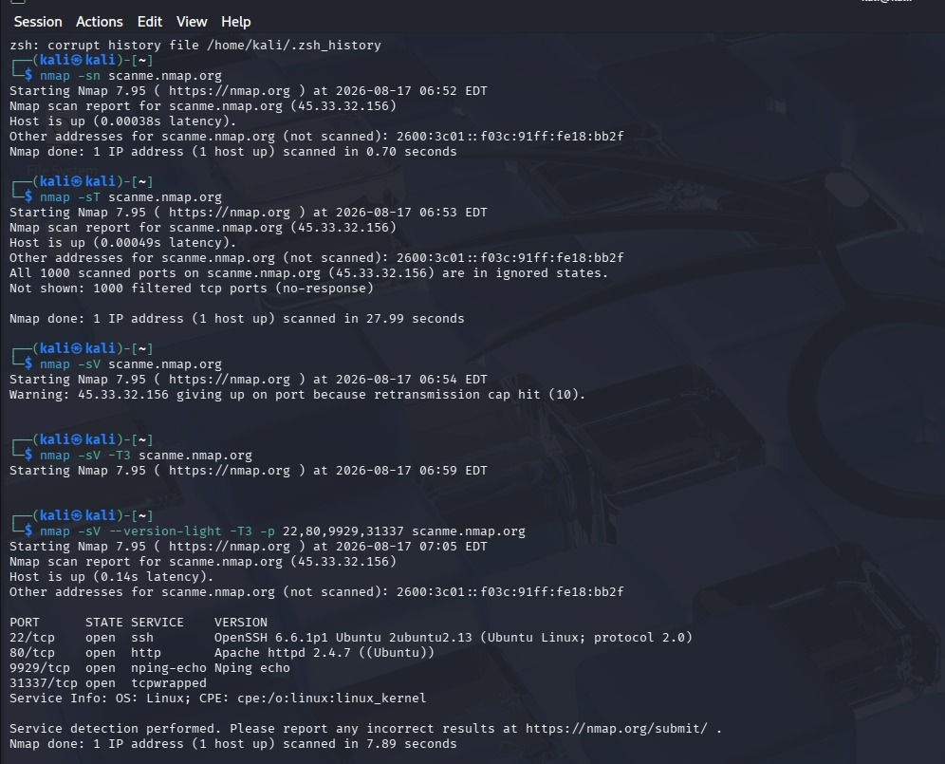





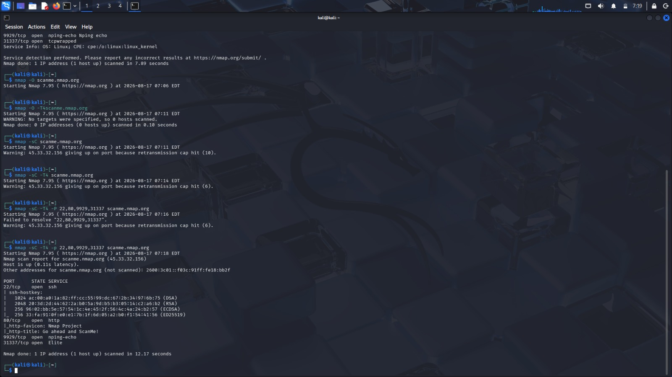



RESULT
The Metasploitable 2 system was successfully enumerated using Nmap. The scan identified open ports, running services, service versions, and operating-system information. The discovered services were categorized according to their potential security impact.The enumeration results provide a foundation for the next stages of an authorized penetration test by helping the tester identify and prioritize potential attack surfaces.

Q2. AIM
To perform comprehensive enumeration of the deliberately vulnerable Linux server 192.168.56.101 (Metasploitable 2) using Nmap, identify open ports, running services, service versions, and operating system information, analyze the purpose and security risk of each service, and determine potential attack surfaces for an authorized penetration test.

OBJECTIVES
- To discover all open TCP ports on the target system.
- To identify the services running on those ports.
- To determine service and application versions.
- To identify the operating system and system information.
- To classify discovered services as High, Medium, or Low risk.
- To understand how enumeration results help select appropriate penetration-testing approaches.

PROCEDURE
Step 1: Check connectivity
ping -c 4 192.168.56.101
This verifies that the Metasploitable 2 machine is reachable.
Step 2: Scan for open ports
sudo nmap -sS -p- 192.168.56.101
The -p- option scans all TCP ports from 1 to 65535.
Step 3: Identify services and versions
sudo nmap -sV -p- 192.168.56.101
Here, -sV performs service and version detection.
Step 4: Perform default script enumeration
sudo nmap -sC -sV -p- 192.168.56.101
This performs Nmap's default NSE scripts along with version detection.
Step 5: Detect the operating system
sudo nmap -O 192.168.56.101
Step 6: Perform comprehensive enumeration
For a combined scan:
sudo nmap -A -p- 192.168.56.101
The -A option enables OS detection, version detection, default scripts, and traceroute.

SERVICE AND RISK ANALYSIS
1. FTP – Port 21
FTP is used for transferring files between systems. An exposed FTP service can become an entry point if anonymous access, weak credentials, misconfiguration, or a vulnerable software version is present.
Risk: High
2. SSH – Port 22
SSH provides encrypted remote administration. It is more secure than Telnet, but weak authentication or an outdated implementation could still create a security risk.
Risk: Medium
3. Telnet – Port 23
Telnet allows remote login but transmits information without strong encryption. Credentials can potentially be exposed during transmission.
Risk: High

4. SMTP – Port 25
SMTP is used for email delivery. Enumeration can reveal information about the mail service and its configuration.
Risk: Medium
5. DNS – Port 53
DNS translates domain names into IP addresses. Misconfigured DNS services may disclose useful information about the network.
Risk: Medium
6. HTTP – Port 80
The HTTP service hosts web applications. Web applications can contain vulnerabilities such as weak authentication, insecure input handling, or outdated components.
Risk: High
7. SMB/NetBIOS – Ports 139 and 445
SMB provides file and printer-sharing functionality. Exposed SMB services can potentially reveal shared resources or vulnerable configurations.
Risk: High
8. RPCbind – Port 111
RPCbind maps RPC services to network ports. It can provide information about other RPC-based services running on the host.
Risk: Medium
9. Remote Shell Services – Ports 512, 513 and 514
rexec, rlogin, and rsh provide remote-access functionality. These legacy services are considered insecure because of their authentication and communication mechanisms.
Risk: High
10. NFS – Port 2049
NFS provides network-based file sharing. Improperly configured exports may expose sensitive files or directories.
Risk: High

OPERATING SYSTEM ENUMERATION
The following command can be used to determine the operating system:
sudo nmap -O 192.168.56.101
A comprehensive scan can also be performed with:
sudo nmap -A 192.168.56.101
Metasploitable 2 is a deliberately vulnerable Linux-based operating system, commonly identified by Nmap as an older Linux distribution/kernel.
The exact OS fingerprint and kernel information should be copied from the Nmap output obtained during the experiment.

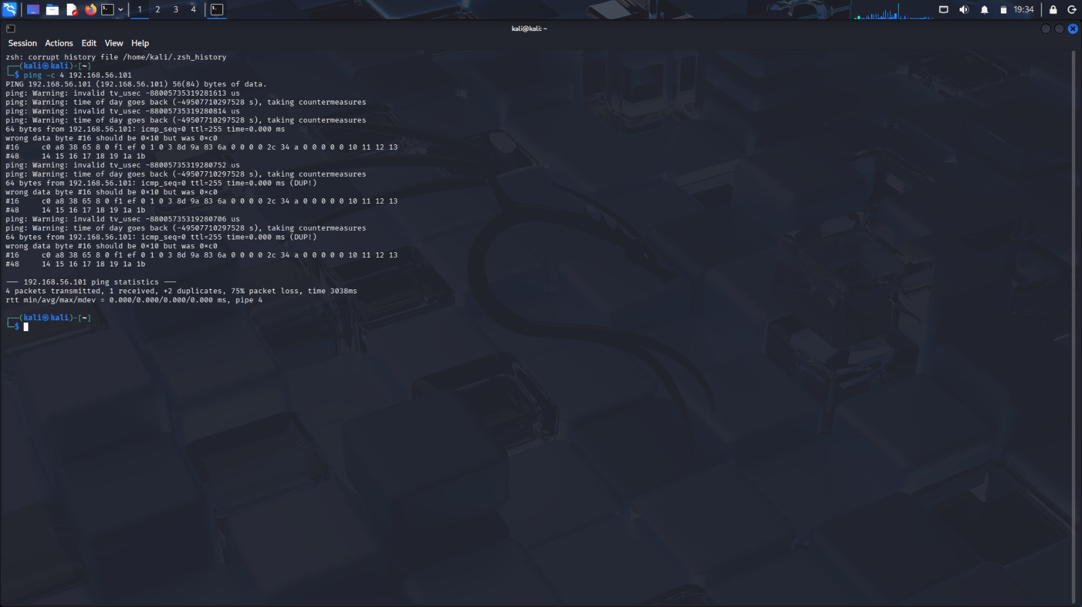

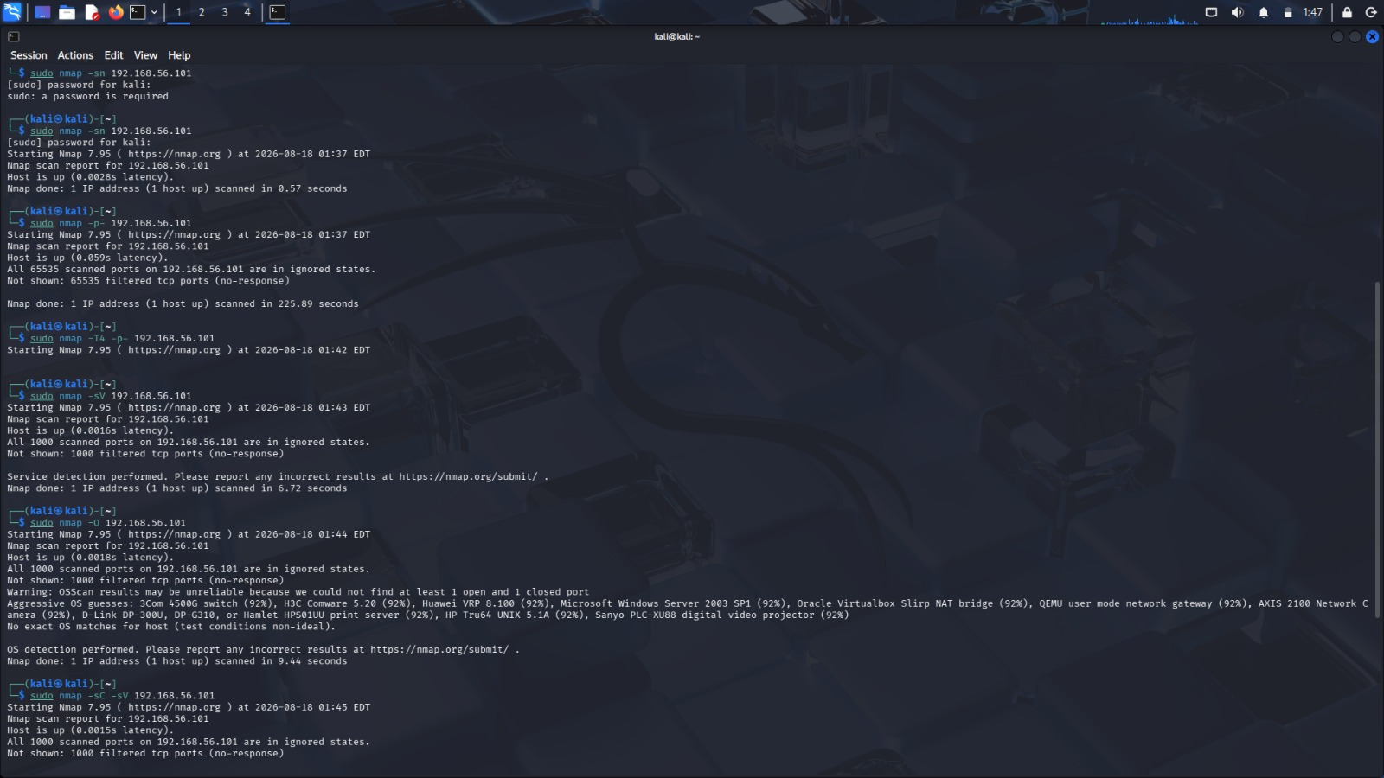









RESULT
The Metasploitable 2 server at 192.168.56.101 was successfully enumerated using Nmap. The enumeration identified multiple open ports, network services, service versions, and operating-system information.The results demonstrate that Metasploitable 2 has a large attack surface containing several high-risk services, particularly legacy remote-access services, file-sharing services, databases, web applications, and remote administration services.
Therefore, Nmap enumeration provides the necessary information for a penetration tester to prioritize targets and select appropriate authorized vulnerability-assessment and exploitation strategies in the isolated laboratory environment.

Q3.Aim
To perform network enumeration of the OWASP Juice Shop server at 192.168.56.103 using Nmap and identify the active host, open ports, running services, service versions, operating system details, and web services exposed by the server.

Objectives
- To verify whether the target host 192.168.56.103 is active.
- To identify open TCP ports on the target system.
- To detect the services running on the discovered ports.
- To identify service versions and possible operating system details.
- To enumerate the web service hosting the OWASP Juice Shop application.
- To analyze the security risks associated with exposed services.
- To identify unnecessary services that may increase the attack surface.
- To recommend measures for reducing network exposure.

Procedure
Step 1: Host Discovery
The following command was used to check whether the target system was active:
sudo nmap -sn 192.168.56.103
This scan confirms whether the host is reachable on the network.
Step 2: Basic Port Scan
A basic Nmap scan was performed to identify commonly exposed ports:
sudo nmap 192.168.56.103
Step 3: Full Port Scan
A complete TCP port scan was performed to identify all open ports:
sudo nmap -p- 192.168.56.103
Step 4: Service and Version Detection
The discovered ports were examined to identify the running services and their versions:
sudo nmap -sV -p <open-port> 192.168.56.103
Step 5: Operating System Detection
Operating system fingerprinting was attempted using:
sudo nmap -O 192.168.56.103
Step 6: Web Service Enumeration
The web service was further examined using HTTP-related scripts:
sudo nmap -sV -p 3000 --script http-title,http-headers,http-methods 192.168.56.103
Step 7: Detailed Enumeration
A combined scan can be used for detailed information:
sudo nmap -sC -sV -O 192.168.56.103

Security Risks Identified
The major risks associated with exposed services include:
- Web Application Attacks – The exposed web service may contain application-level vulnerabilities.
- Information Disclosure – Service banners and HTTP headers may reveal technology details.
- Administrative Access Exposure – SSH or management interfaces may provide unauthorized access opportunities if not properly secured.
- Unnecessary Open Ports – Unused services increase the overall attack surface.
- Outdated Software – Old service versions may contain known vulnerabilities.
- Database Exposure – Direct access to database services could expose sensitive application data.

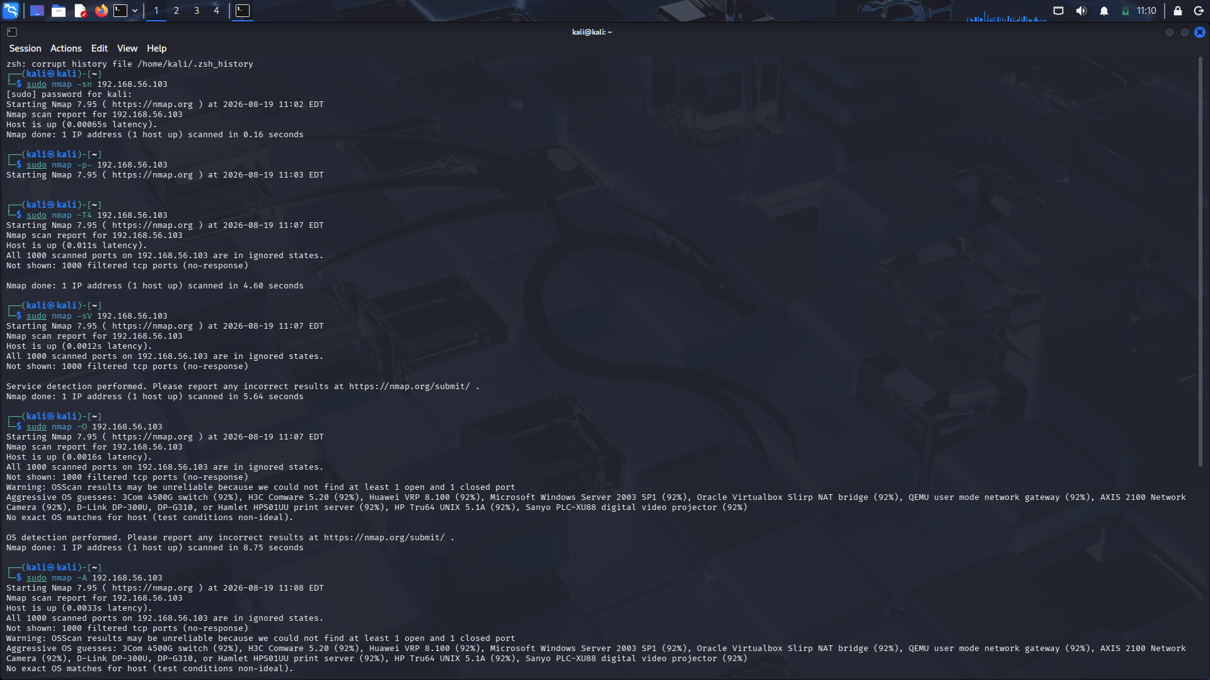







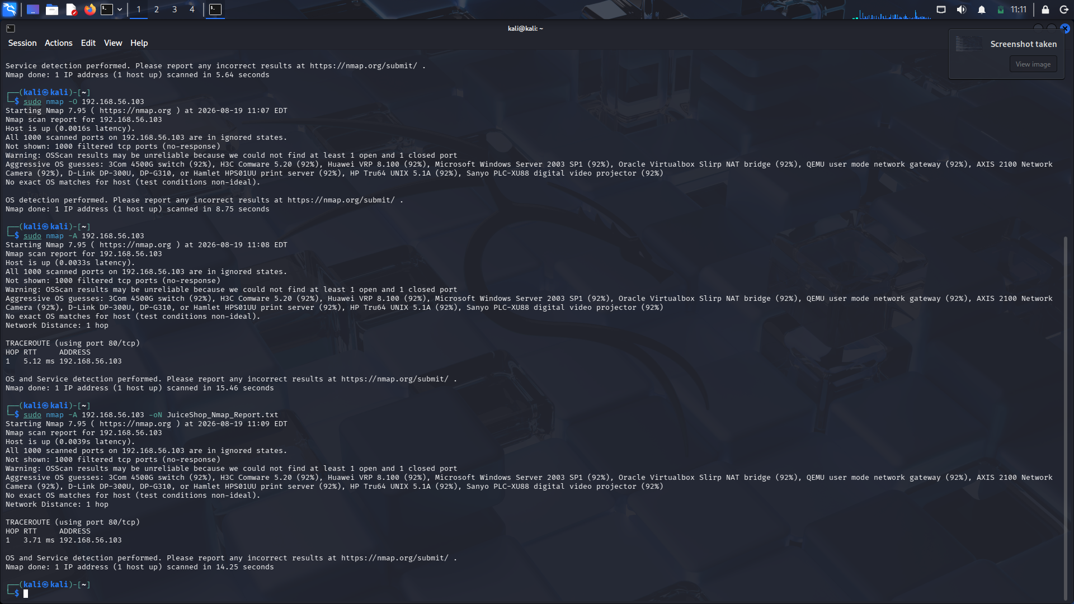



Result
The Nmap enumeration of 192.168.56.103 successfully identified the active host, open ports, running services, and web application exposure. The analysis helped identify potential security risks and unnecessary services that could increase the attack surface.

Q4.

Aim
To perform network enumeration of the gateway device at 192.168.56.1 using Nmap and identify open ports, running services, management interfaces, and possible operating system details.

Objectives
- To check whether the gateway device is active.
- To identify open ports on the target.
- To detect running services and service versions.
- To identify management services such as SSH, Telnet, HTTP, HTTPS, and SNMP.
- To perform operating system fingerprinting.
- To analyze the security risks of exposed services.
- To recommend measures to secure the gateway device.

Procedure
1. Basic Port Scan
The following command was used to identify commonly open ports:
sudo nmap 192.168.56.1
2. Service and Version Detection
sudo nmap -sV 192.168.56.1
3. Operating System Detection
sudo nmap -O 192.168.56.1
4. Script-Based Enumeration
sudo nmap -sC -sV -O 192.168.56.1
5. Management Service Scan
sudo nmap -sV -p 22,23,80,161,443 192.168.56.1
The above command checks common management services:
- Port 22 – SSH
- Port 23 – Telnet
- Port 80 – HTTP
- Port 161 – SNMP
- Port 443 – HTTPS

Service Analysis
SSH – Port 22
SSH provides secure remote administration. If exposed unnecessarily or protected by weak credentials, it may allow unauthorized access attempts. SSH access should be restricted to trusted administrators.
Telnet – Port 23
Telnet is insecure because communication, including login credentials, may be transmitted without encryption. If Telnet is enabled, it should be disabled and replaced with SSH.
HTTP – Port 80
HTTP may provide a web-based management interface. Since HTTP communication is not encrypted, sensitive management information could be exposed. HTTPS should be preferred.
HTTPS – Port 443
HTTPS provides encrypted access to a web management interface. However, weak passwords, outdated firmware, or poor configuration can still create security risks.

SNMP – Port 161
SNMP can provide information about the gateway, network interfaces, and device configuration. Weak or default community strings can lead to information disclosure. SNMP access should be restricted to authorized management systems.

Security Recommendations
- Disable unnecessary ports and services.
- Disable Telnet and use SSH for remote administration.
- Restrict SSH access to authorized IP addresses.
- Use strong and unique administrator passwords.
- Change default login credentials.
- Use HTTPS instead of HTTP for web management.
- Restrict SNMP access and use secure configurations.
- Keep the gateway firmware and software updated.
- Configure firewall rules to block unnecessary management ports.
- Separate management traffic from normal network traffic.
- Regularly scan and monitor the gateway for unexpected services.

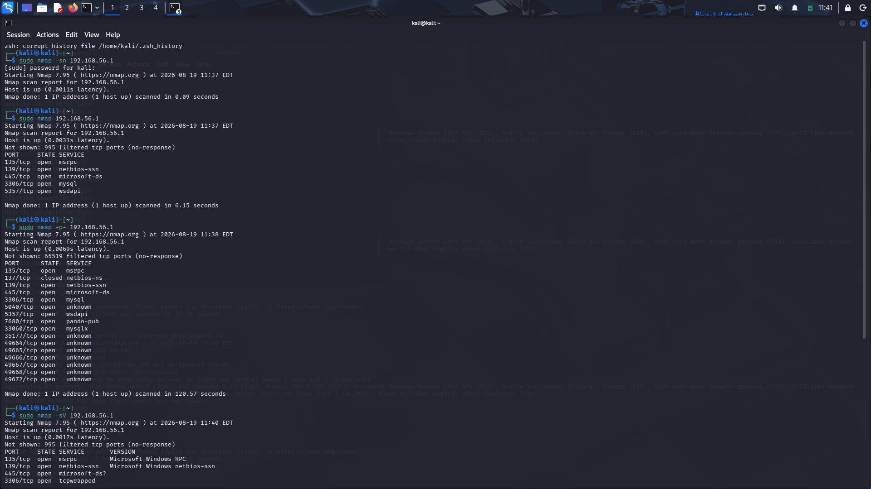





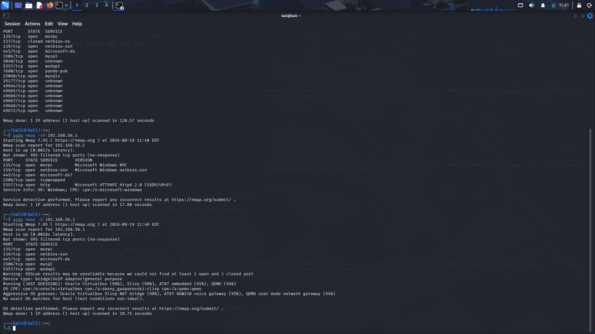


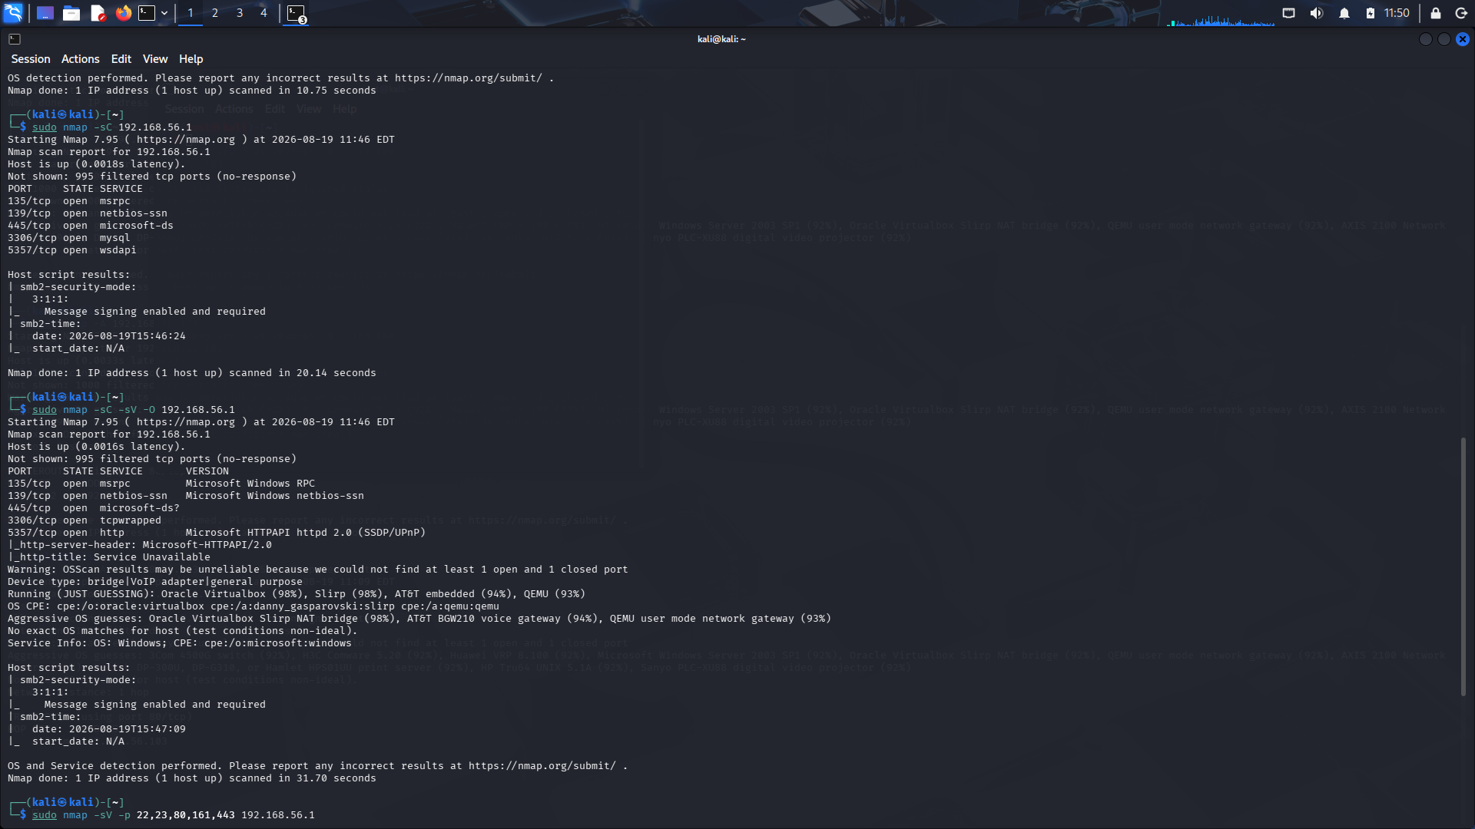



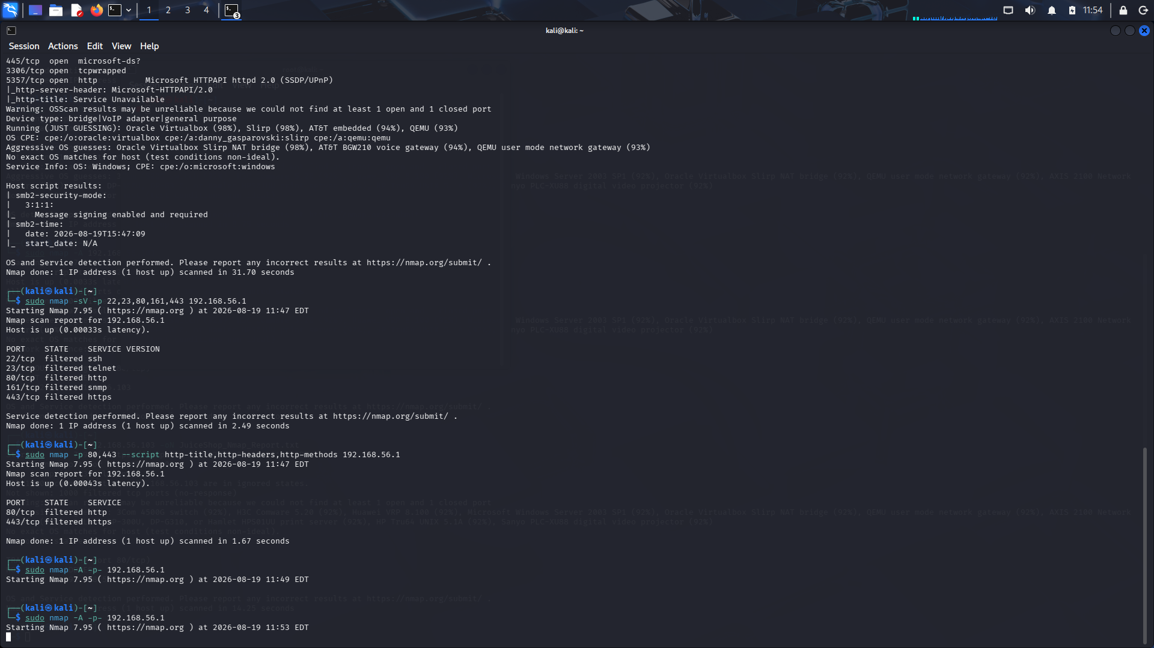



Result
The Nmap enumeration of 192.168.56.1 successfully identified the accessible ports and network services on the gateway device. The analysis helps detect exposed management interfaces and potential security risks. Unnecessary services should be disabled, and management access should be restricted and secured to reduce the risk of unauthorized access and network compromise.

Q5.
Aim
To perform a comprehensive Nmap enumeration of the network gateway device at 192.168.56.1 to identify open ports, running services, management interfaces, operating system details, and potential security risks.

Objectives
- To check whether the target gateway is active.
- To identify open ports on 192.168.56.1.
- To detect the services and versions running on the gateway.
- To perform operating system fingerprinting.
- To perform script-based enumeration.
- To identify management interfaces such as SSH, Telnet, SNMP, HTTP, and HTTPS.
- To analyze the security risks associated with exposed services.
- To recommend security measures to reduce the attack surface.

Procedure
Step 1: Host Discovery
Check whether the gateway device is active.
sudo nmap -sn 192.168.56.1
Step 2: Port Scanning
Perform a basic port scan:
sudo nmap 192.168.56.1
Step 3: Service and Version Detection
Identify the services and their versions:
sudo nmap -sV 192.168.56.1
Step 4: Operating System Detection
Attempt to identify the operating system:
sudo nmap -O 192.168.56.1
Step 5: Script-Based Enumeration
Run Nmap default scripts:
sudo nmap -sC 192.168.56.1
Step 6: Comprehensive Enumeration
Combine script scanning, service detection, and OS detection:
sudo nmap -sC -sV -O 192.168.56.1
Step 7: Management Service Scan
Check common management ports:
sudo nmap -sV -p 22,23,80,161,443 192.168.56.1
The ports represent:
- 22 – SSH
- 23 – Telnet
- 80 – HTTP
- 161 – SNMP
- 443 – HTTPS
Step 8: Web Management Enumeration
Check the HTTP and HTTPS management interfaces:
sudo nmap -p 80,443 --script http-title,http-headers,http-methods 192.168.56.1

Service Analysis
SSH – Port 22
SSH provides encrypted remote administration. If weak passwords, default credentials, or poor access controls are used, unauthorized users may attempt to gain administrative access.
Recommendation: Restrict SSH to trusted IP addresses and authorized administrators.
Telnet – Port 23
Telnet transmits communication without encryption and may expose usernames and passwords.
Recommendation: Disable Telnet and use SSH instead.
SNMP – Port 161
SNMP can expose information about network interfaces, device configuration, and network status. Weak or default community strings can result in information disclosure.
Recommendation: Restrict SNMP access to authorized management systems and use secure SNMP configurations.
HTTP – Port 80
HTTP may provide a web-based gateway management interface. Since communication is unencrypted, login credentials or management traffic could potentially be exposed.
Recommendation: Disable HTTP management where possible and use HTTPS.
HTTPS – Port 443
HTTPS provides encrypted web-based administration. However, weak passwords, outdated firmware, or configuration weaknesses can still create security risks.

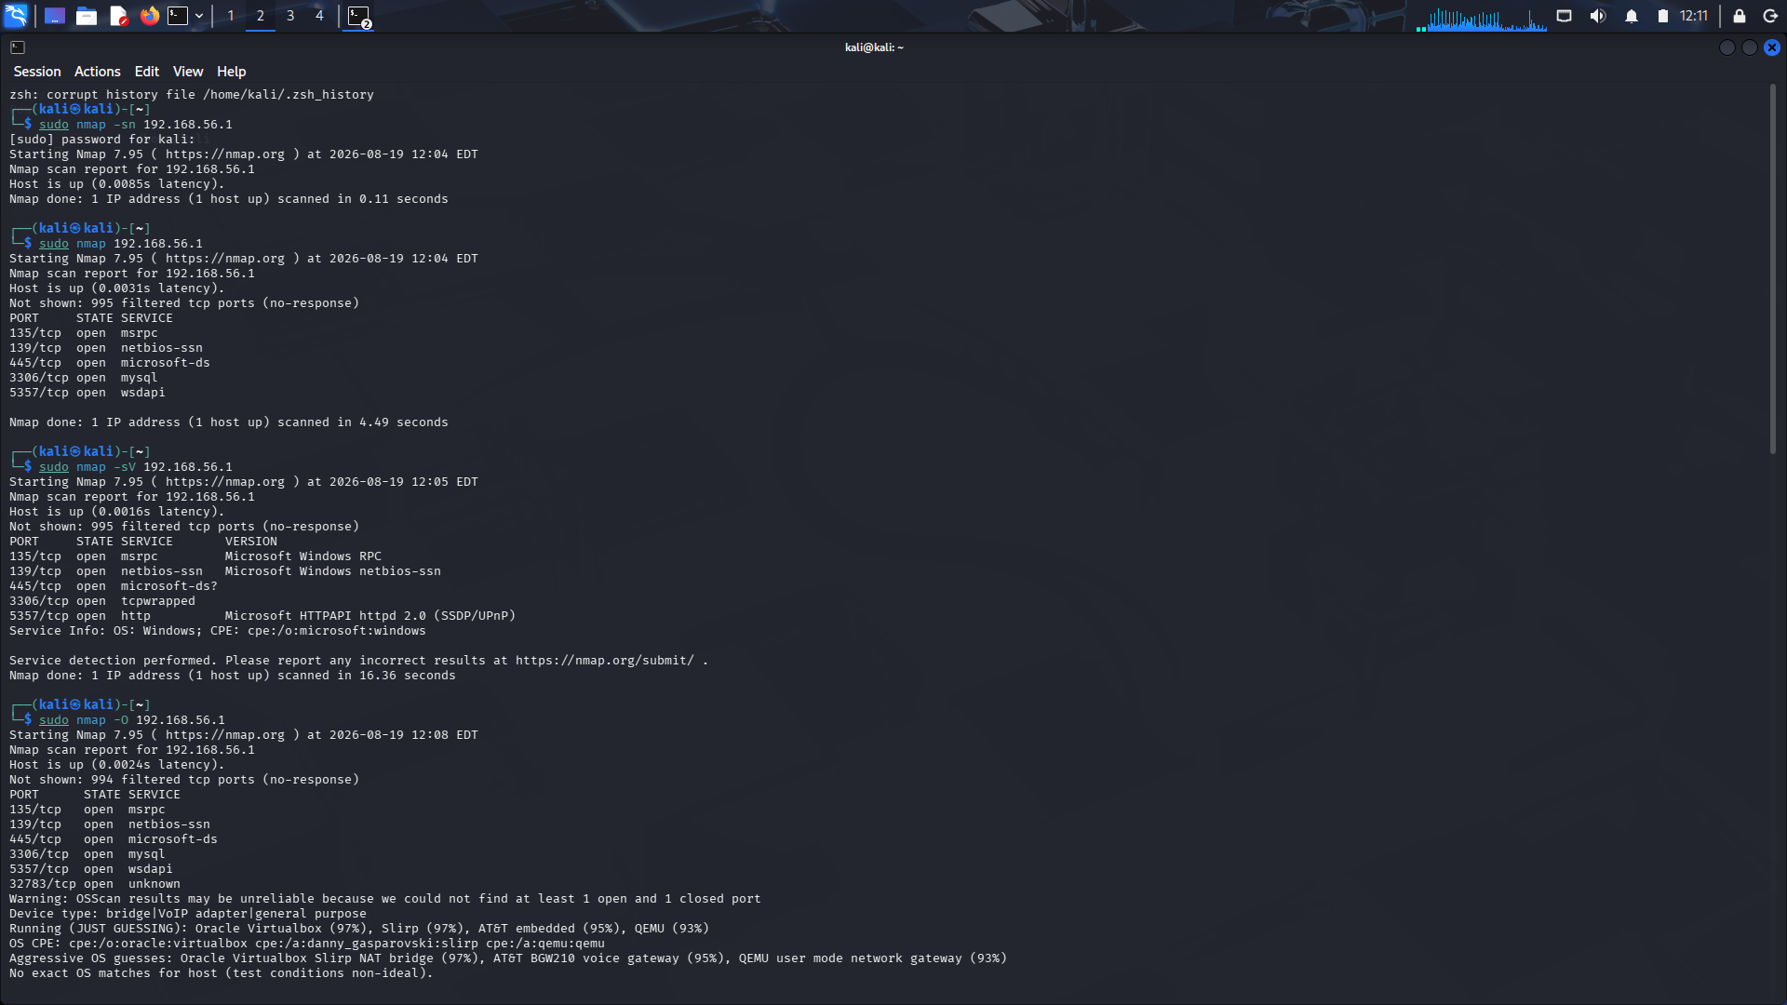





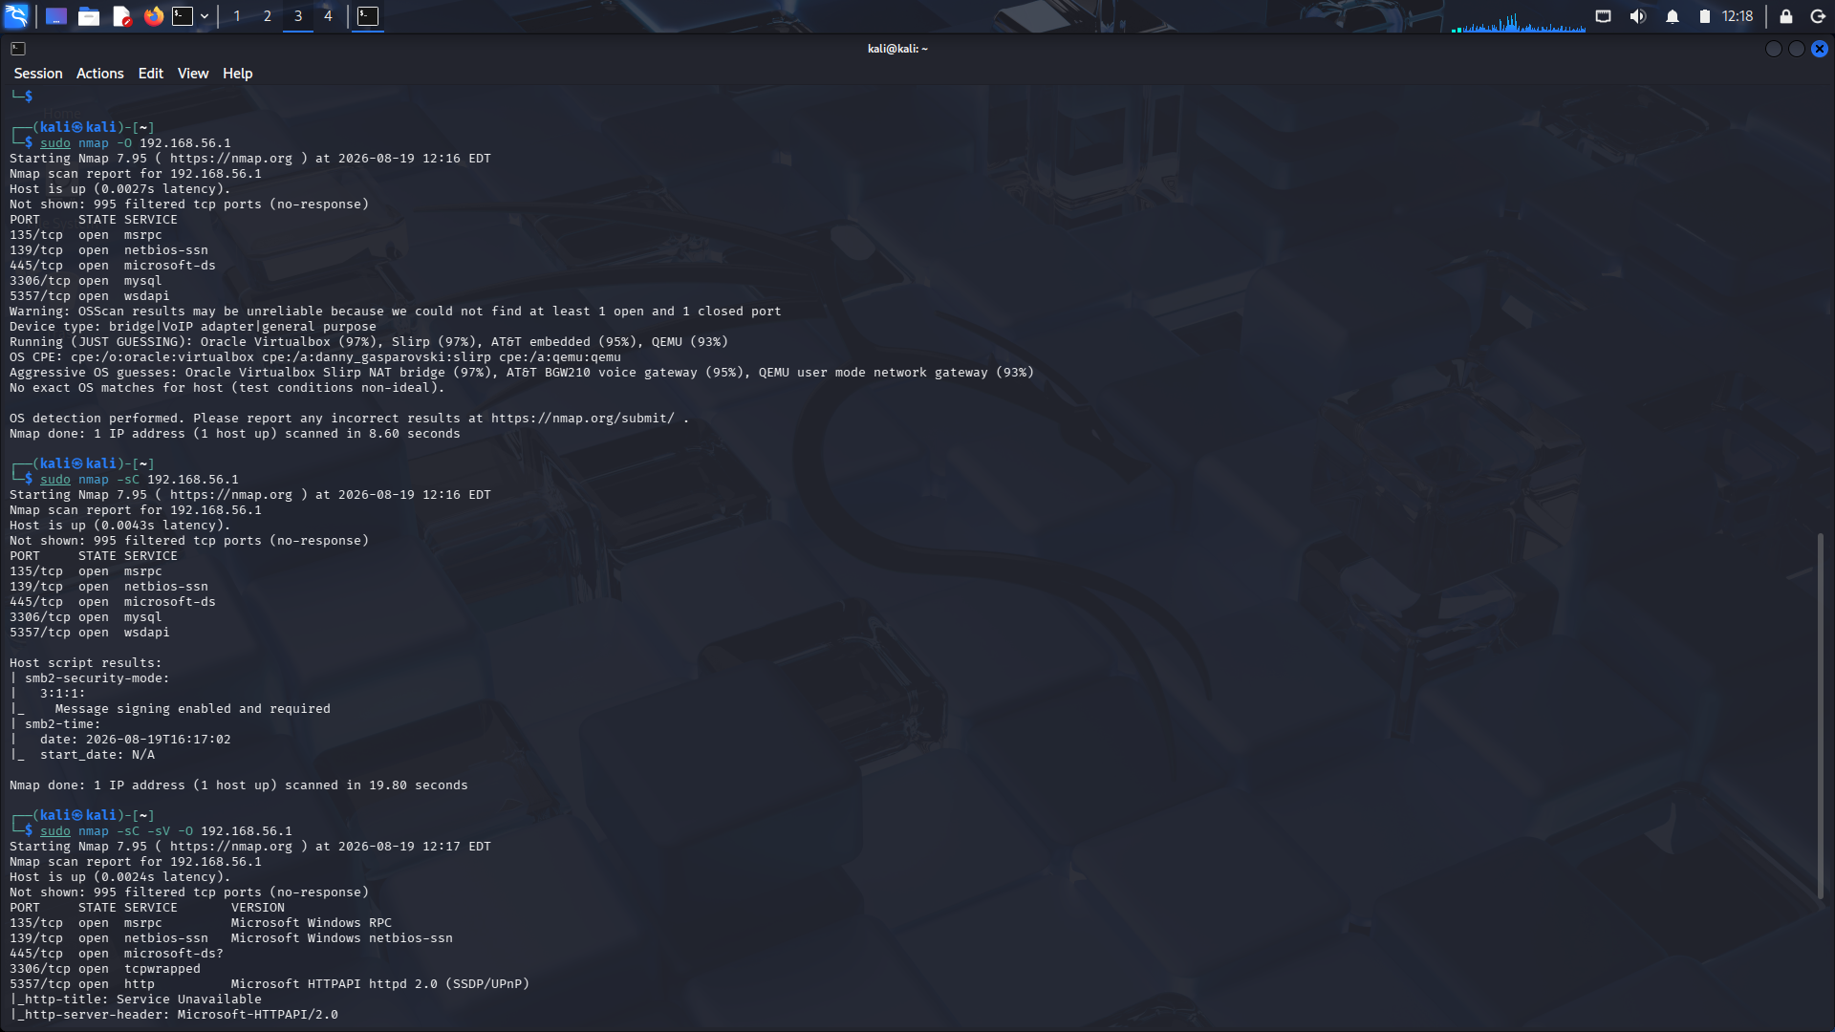



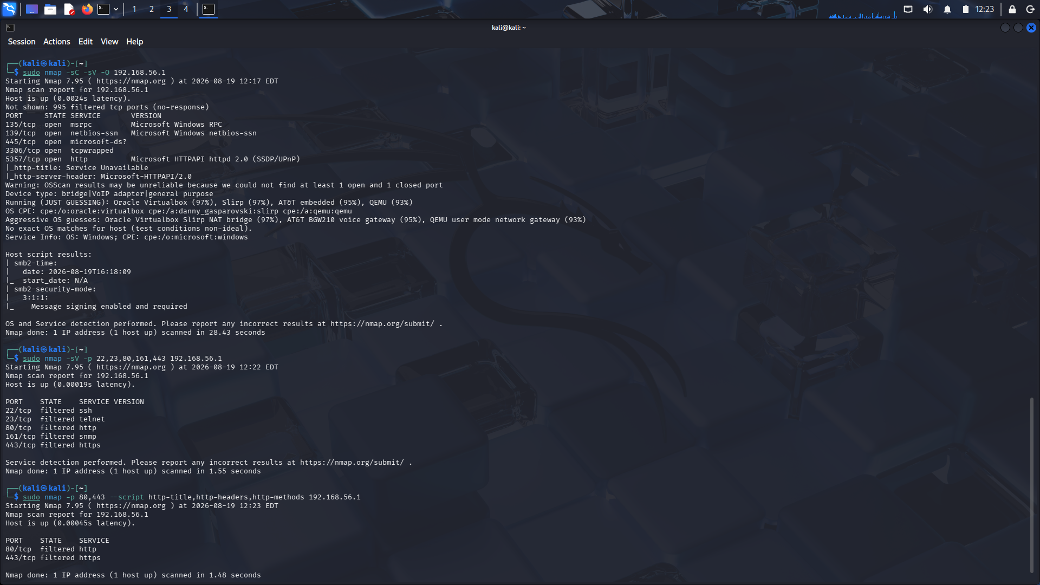



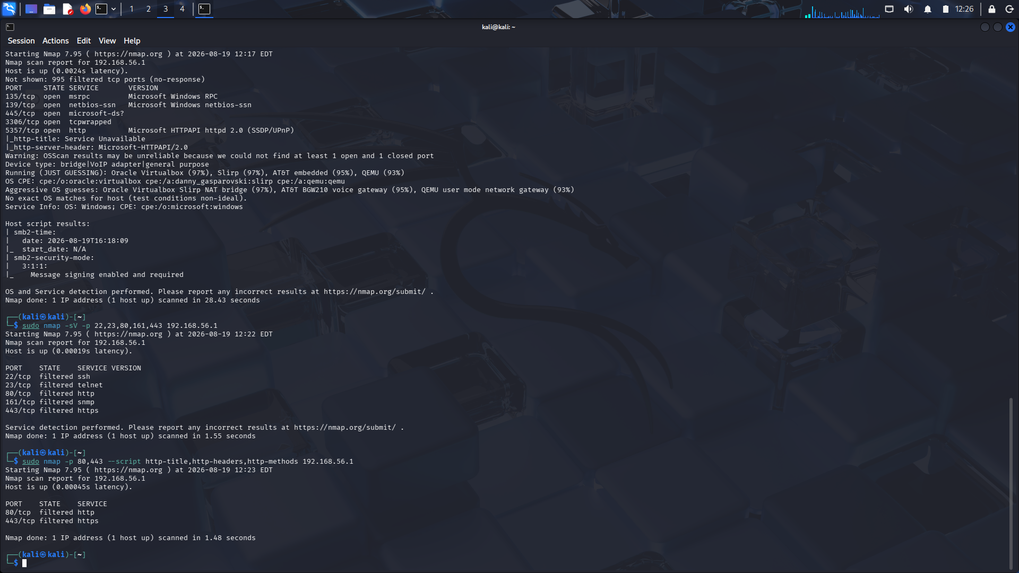
Result
The Nmap enumeration of 192.168.56.1 was performed to identify open ports, running services, management interfaces, and possible operating system information. The analysis helps identify unnecessary exposed services and potential security risks. Restricting management access, disabling unused services, using secure protocols, and applying proper firewall and authentication controls can reduce the risk of gateway compromise.

